PREPARATION AND MAINTANECE OF ZOHO BOOKS OF

ACCOUNTS FOR TECHPRO SOLUTIONS

(INFORMATION TECHNOLOGY - INDUSTRY)

**1.INTRODUCTION:**

Tech Pro Solution, a dynamic and forward-thinking company, relies on meticulous financial management to drive its success. The preparation and maintenance of Zoho Books play a pivotal role in ensuring the accuracy and efficiency of Tech Pro Solution's accounting processes. This involves a strategic approach encompassing account setup, customized chart of accounts, seamless integration of banking transactions, and utilization of Zoho Books features for invoicing, expense management, sales orders, and more.

**2.PURPOSE:**

* **Official Website:** Explore the company's official website, which often contains information about its mission, vision, and values.
* **Mission Statement:** Look for a mission statement, as companies commonly articulate their core purposes and goals in such statements.
* **Public Documentation:** Check any publicly available documentation, reports, or press releases that might provide insights into the company's purposes.
* **Contacting the Company:** If needed, consider reaching out to TechPro Solution directly through their official communication channels for the most accurate and up-to-date information.

**3.PROBLEM DEFINITION & DESIGN THINKING:**

**3.1 Empathy Map**

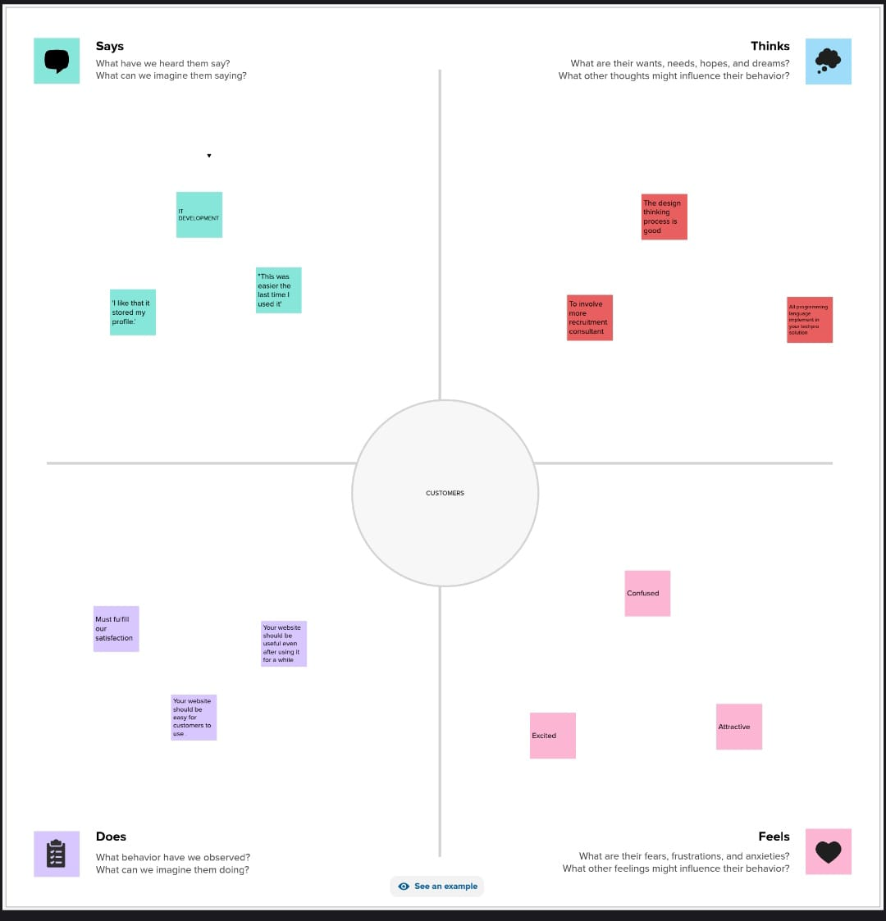

**3.2 Ideation & Brainstorming Map**

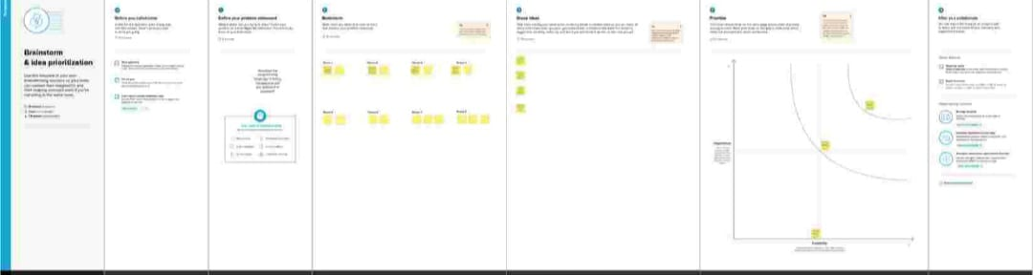

**4.RESULT:**

**Output**

The output of profit and loss for Techpro Solutions Company from 01/04/2023 To 31/03/2024 with the profit of rs. 11,95,000.00

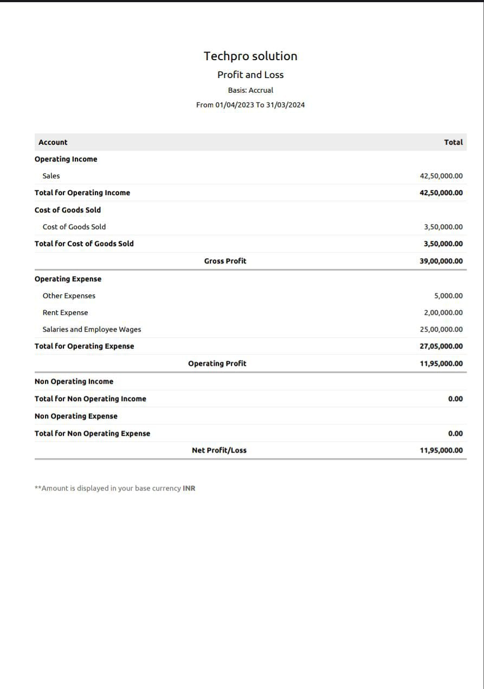

The balance sheet as on 31/03/2024 with the Total Assets and the Total Liabilities of rs. 64,23,000.00



**5. ADVANTAGES & DISADVANTAGES:**

**ADVANTAGES**

* **Increased Efficiency:** Technology solutions can streamline business processes, reducing manual effort and saving time.

* **Enhanced Accuracy:** Automated systems reduce the risk of human error in tasks like data entry and calculations.
* **Improved Decision-Making:** Access to real-time data and analytics can empower informed decision-making at various levels of the organization.
* **Scalability:** Many technology solutions are designed to scale with the growth of the business, accommodating increased workload and demands.
* **Customer Engagement:** Technology can be leveraged to enhance customer interactions through platforms like customer relationship management (CRM) systems.

**Disadvantages:**

* **Implementation Costs:** Initial setup costs and investment in technology infrastructure can be significant.
* **Learning Curve:** Employees may require training to adapt to new technologies, causing a temporary decrease in productivity during the transition.
* **Security Concerns:** The reliance on technology introduces cybersecurity risks, requiring robust measures to protect sensitive data.
* **Dependency on Technology:** Technical issues or system failures could disrupt operations if not addressed promptly.
* **Upkeep and Maintenance:** Regular updates, maintenance, and potential system upgrades can add to ongoing costs.

**6.APPLICATION:**

* Financial Record –Keeping
* Invoicing
* Expense Management
* Bank Integration
* Sales and Purchase orders
* Inventory Tracking
* Tax Compliance
* Financial Reporting
* Multi-Currency Transactions
* Budgeting
* Collaboration and User Roles
* Time Tracking
* Integration with Other Zoho Apps
* Mobile Accessibility
* Automation

**7.CONCLUSION:**

Preparation and maintance of zoho books for Techpro Solutions for Information Techonolgy Industry define the invoicing and payments. It also maintains the financial transparency with the profit and loss accounts and balance sheet.